DATA CLEANING AND VISUALIZATION USING THE TITANIC DATASET
Introduction
Data cleaning and visualization are essential steps in data science. Raw datasets often contain missing values, duplicate records, and inconsistencies that can affect analysis. Data cleaning improves the quality of the dataset, while data visualization helps understand patterns and relationships within the data.
In this project, the Titanic dataset is used to perform data cleaning and exploratory data analysis (EDA). Python libraries such as Pandas, NumPy, Matplotlib, and Seaborn are used to clean the data and create visualizations.

Objectives
- To load the Titanic dataset.
- To identify and handle missing values.
- To remove duplicate records.
- To prepare a clean dataset for analysis.
- To visualize the data using graphs.
- To understand the relationships between different variables.
Tools and Technologies Used
- Programming Language: Python
- Platform: Google Colab
- Libraries:
  - Pandas
  - NumPy
  - Matplotlib
  - Seaborn
Dataset
- Titanic Dataset (titanic.csv)

Data Visualization
After cleaning the dataset, the following visualizations were created:
- Histogram: Shows the distribution of passengers' ages.
- Box Plot: Identifies outliers in the Age column.
- Correlation Heatmap: Displays the relationships between numerical features.
Result :
Upload the Titanic dataset (titanic.csv)
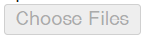
• titanic.csv(text/csv) - 60302 bytes, last modified: 7/6/2026 - 100% done
Saving titanic.csv to titanic (1).csv

First 5 Rows:
PassengerId Survived Pclass \
0 1 0 3
1 2 1 1
2 3 1 3
3 4 1 1
4 5 0 3

Name Sex Age SibSp \
0 Braund, Mr. Owen Harris male 22.0 1
1 Cumings, Mrs. John Bradley (Florence Briggs Th... female 38.0 1
2 Heikkinen, Miss. Laina female 26.0 0
3 Futrelle, Mrs. Jacques Heath (Lily May Peel) female 35.0 1
4 Allen, Mr. William Henry male 35.0 0

Parch Ticket Fare Cabin Embarked
0 0 A/5 21171 7.2500 NaN S
1 0 PC 17599 71.2833 C85 C
2 0 STON/O2. 3101282 7.9250 NaN S
3 0 113803 53.1000 C123 S
4 0 373450 8.0500 NaN S

Dataset Information:
<class 'pandas.core.frame.DataFrame'>
RangeIndex: 891 entries, 0 to 890
Data columns (total 12 columns):
# Column Non-Null Count Dtype
--- ------ -------------- -----
0 PassengerId 891 non-null int64
1 Survived 891 non-null int64
2 Pclass 891 non-null int64
3 Name 891 non-null object
4 Sex 891 non-null object
5 Age 714 non-null float64
6 SibSp 891 non-null int64
7 Parch 891 non-null int64
8 Ticket 891 non-null object
9 Fare 891 non-null float64
10 Cabin 204 non-null object
11 Embarked 889 non-null object
dtypes: float64(2), int64(5), object(5)
memory usage: 83.7+ KB
None

Statistical Summary:
PassengerId Survived Pclass Age SibSp \
count 891.000000 891.000000 891.000000 714.000000 891.000000
mean 446.000000 0.383838 2.308642 29.699118 0.523008
std 257.353842 0.486592 0.836071 14.526497 1.102743
min 1.000000 0.000000 1.000000 0.420000 0.000000
25% 223.500000 0.000000 2.000000 20.125000 0.000000
50% 446.000000 0.000000 3.000000 28.000000 0.000000
75% 668.500000 1.000000 3.000000 38.000000 1.000000
max 891.000000 1.000000 3.000000 80.000000 8.000000

Parch Fare
count 891.000000 891.000000
mean 0.381594 32.204208
std 0.806057 49.693429
min 0.000000 0.000000
25% 0.000000 7.910400
50% 0.000000 14.454200
75% 0.000000 31.000000
max 6.000000 512.329200

Missing Values:
PassengerId 0
Survived 0
Pclass 0
Name 0
Sex 0
Age 177
SibSp 0
Parch 0
Ticket 0
Fare 0
Cabin 687
Embarked 2
dtype: int64

Missing Values After Cleaning:
PassengerId 0
Survived 0
Pclass 0
Name 0
Sex 0
Age 0
SibSp 0
Parch 0
Ticket 0
Fare 0
Embarked 0
dtype: int64

Cleaned dataset saved as 'cleaned_titanic.csv'
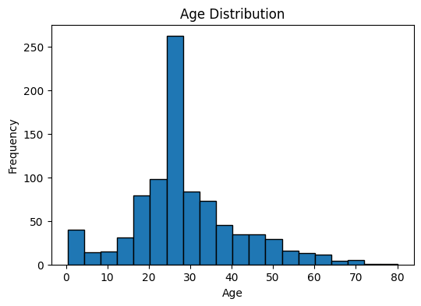
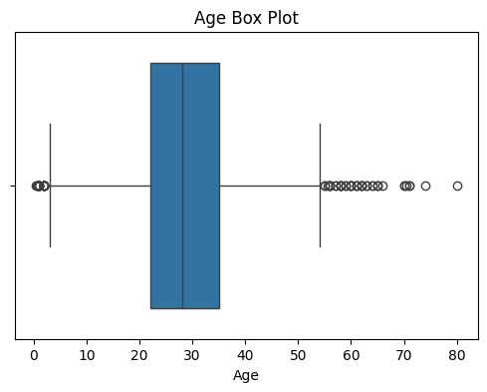
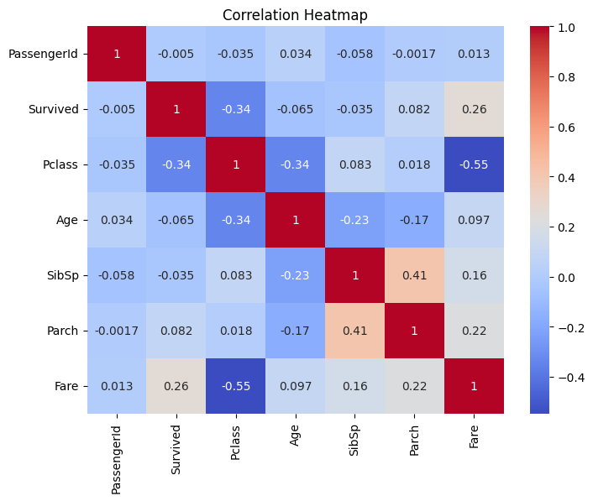

Cleaned Dataset Preview:
PassengerId Survived Pclass \
0 1 0 3
1 2 1 1
2 3 1 3
3 4 1 1
4 5 0 3

Name Sex Age SibSp \
0 Braund, Mr. Owen Harris male 22.0 1
1 Cumings, Mrs. John Bradley (Florence Briggs Th... female 38.0 1
2 Heikkinen, Miss. Laina female 26.0 0
3 Futrelle, Mrs. Jacques Heath (Lily May Peel) female 35.0 1
4 Allen, Mr. William Henry male 35.0 0

Parch Ticket Fare Embarked
0 0 A/5 21171 7.2500 S
1 0 PC 17599 71.2833 C
2 0 STON/O2. 3101282 7.9250 S
3 0 113803 53.1000 S
4 0 373450 8.0500 S

🎉 Project Completed Successfully!

Conclusion
This project demonstrated the importance of data cleaning and visualization in data analysis. By handling missing values, removing duplicates, and creating graphs, the dataset became more accurate and useful for future analysis. The project improved understanding of data preprocessing techniques and basic exploratory data analysis using Python.
Future Scope
- Apply machine learning models on the cleaned dataset.
- Perform advanced exploratory data analysis.
- Predict passenger survival using classification algorithms.
References
- Kaggle Titanic Dataset
- Python Documentation
- Pandas Documentation
- Matplotlib Documentation
Seaborn Documentation

